Patient Discharge: Resident EPIC workflow

Use the Admission/Discharge/Transfer (ADT) Navigator for discharging patients.
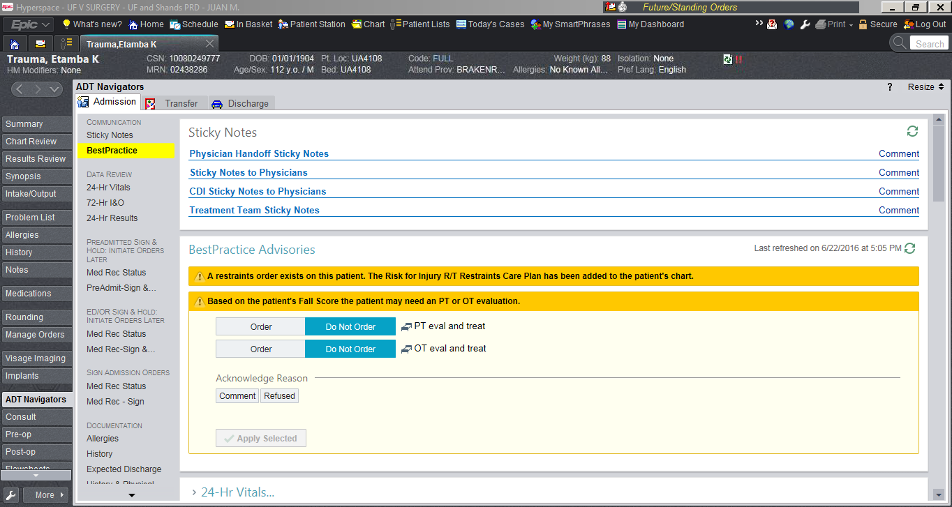

Next click on the “Discharge” tab:
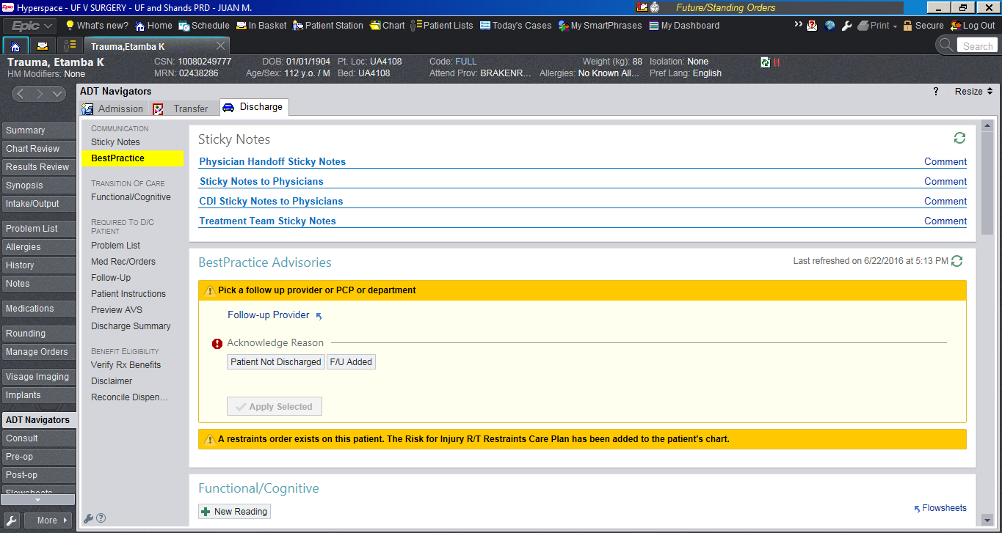

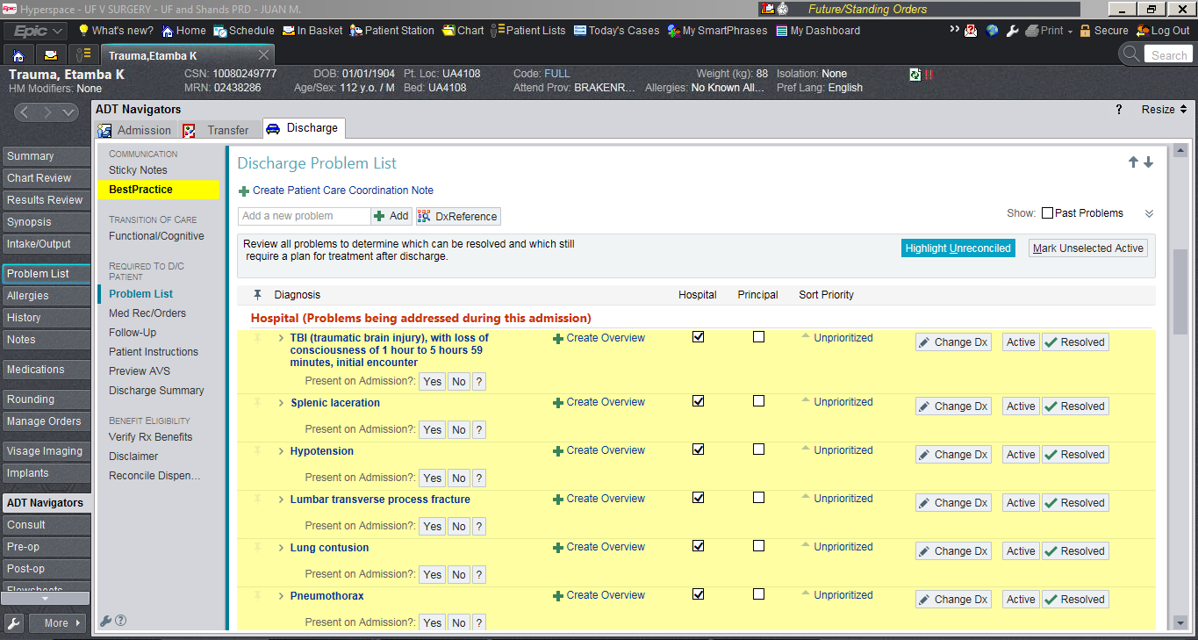
Start with the “Problem List” subtab. Review the problems pertinent to and added on this hospitalizations. Be sure to choose the “Principal” problem for the hospitalization:

Next proceed with the “Follow-Up” subtab. Follow-up appointments made during the hospitalizations should show up here. Other internal follow-up appointments may be added in this tab. However, this DOES NOT replace appointment requests. Appointment requests are made via the “Med Rec/Orders” process.
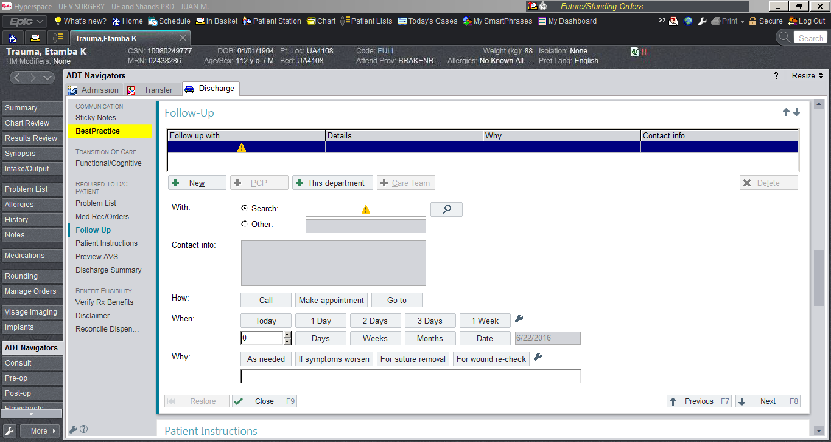

The “Patient Instructions” subtab can be used to add the patient discharge instructions. However, we are moving away from using this section as the location to add patient instructions. This will be presented below. Ultimately, this section will only be used by other providers, such as: SW, CM, PT/OT, etc.
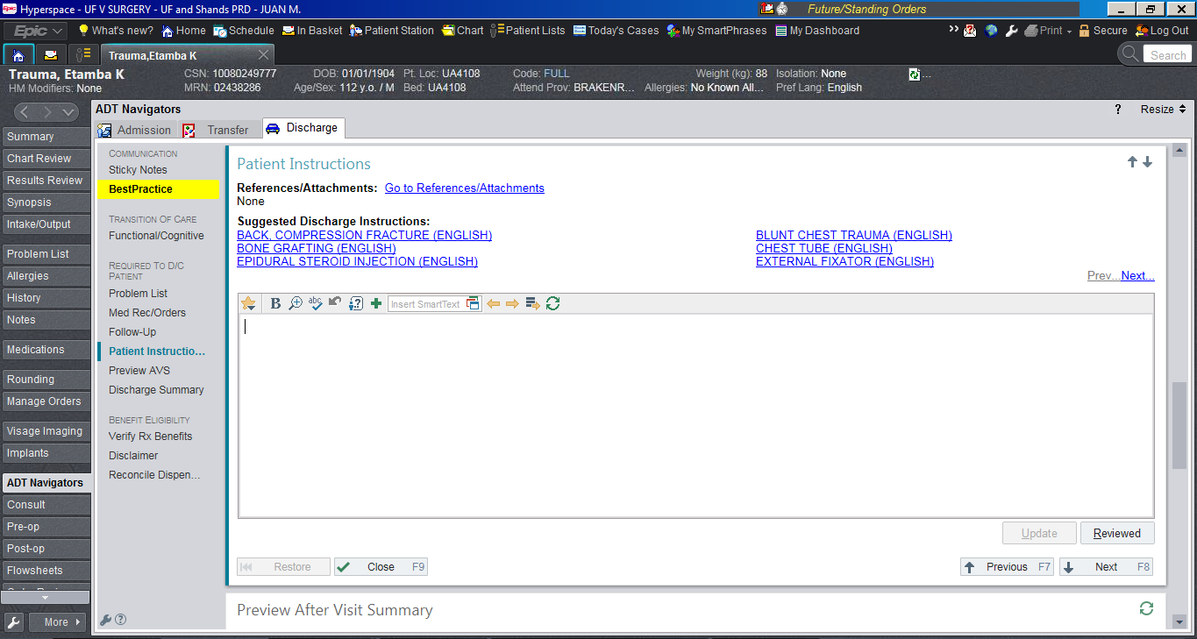

Next, proceed to the “Med Rec/Orders” subtab to reconcile medications, place new orders and discharge patient using the Surgery Discharge Order Set.
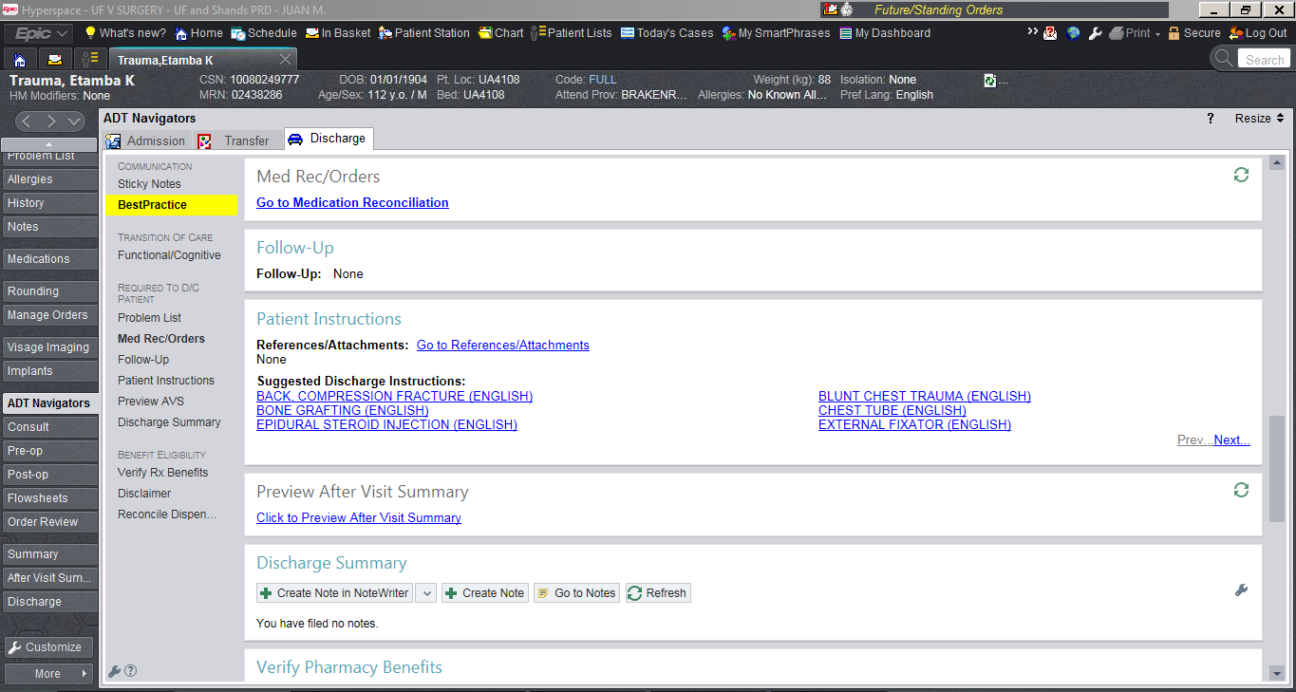

The 1st section on “Med Rec/Orders” is “Review Prior to Admission Medications”. This should generally be completed by the admitting resident and/or the admitting nurse. Please review to ensure accuracy of medications prior to patient’s admission as these medications will carry through the admission and discharge. Review and click “Next”.
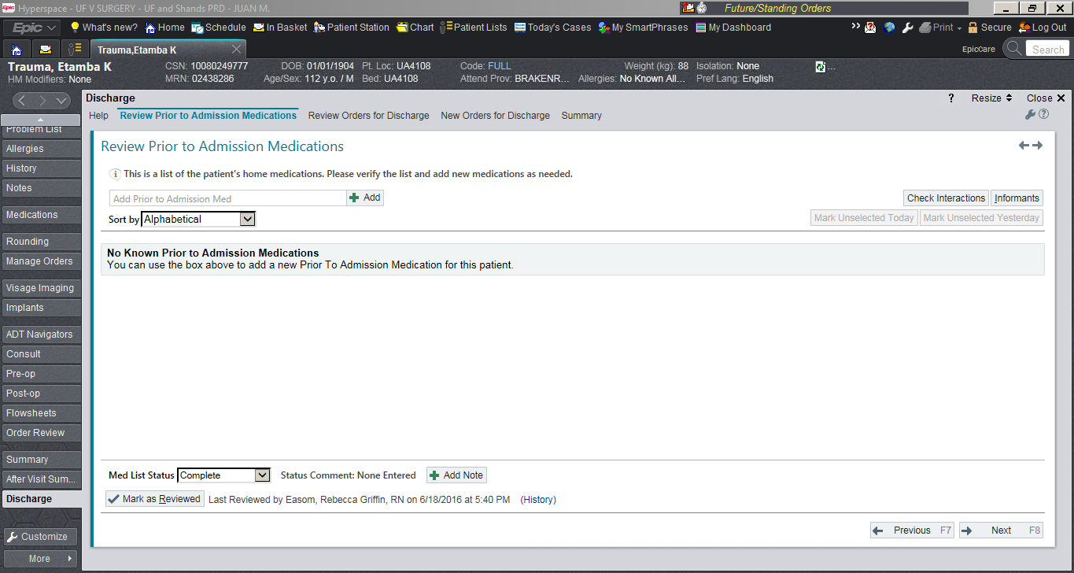

The 2nd section on “Med Rec/Orders” is “Review Orders for Discharge”. Here you may “Prescribe” or “Don’t Prescribe” medications that the patient is currently taking while in-house. You may also “Modify and Prescribe” medications that the patient is currently taking while in-house, meaning, you may modify the dose/schedule of current in-patient medications being prescribed to the patient.
Additionally, you can also click “Modify Home Rx” to adjust medications the patient was taking prior to his/her hospitalization (hence the importance of reviewing ‘prior to admission medications’). You may also chose “Keep Taking” to indicate an outpatient medication may be continued (no need to write a prescription for these unless the patient needs a refill). Finally, you can also chose “Stop Taking” to remove outpatient medications the patient no longer needs to take. Prescribing medications will require a dose, a schedule, a quantity, and refills. No refills available for narcotics. Review and click “Next”.
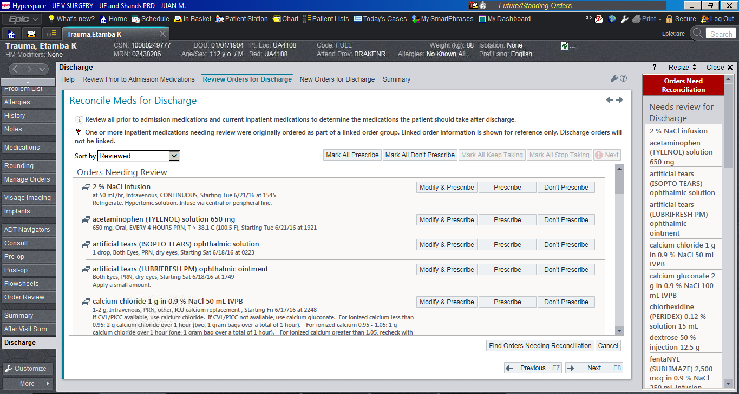

The 3rd section on “Med Rec/Orders” is “New Orders for Discharge”. Here you may place “Additional Discharge Orders” such as: other medications not currently being given in-house (or a variation on a medication being given in-house; these may be different due to insurance reasons), appointment requests of for internal follow-up appointments, etc. Additionally, in this section you will use the “Surgery Discharge Adult UF” Order Set which will be described below. Review and click “Next”.
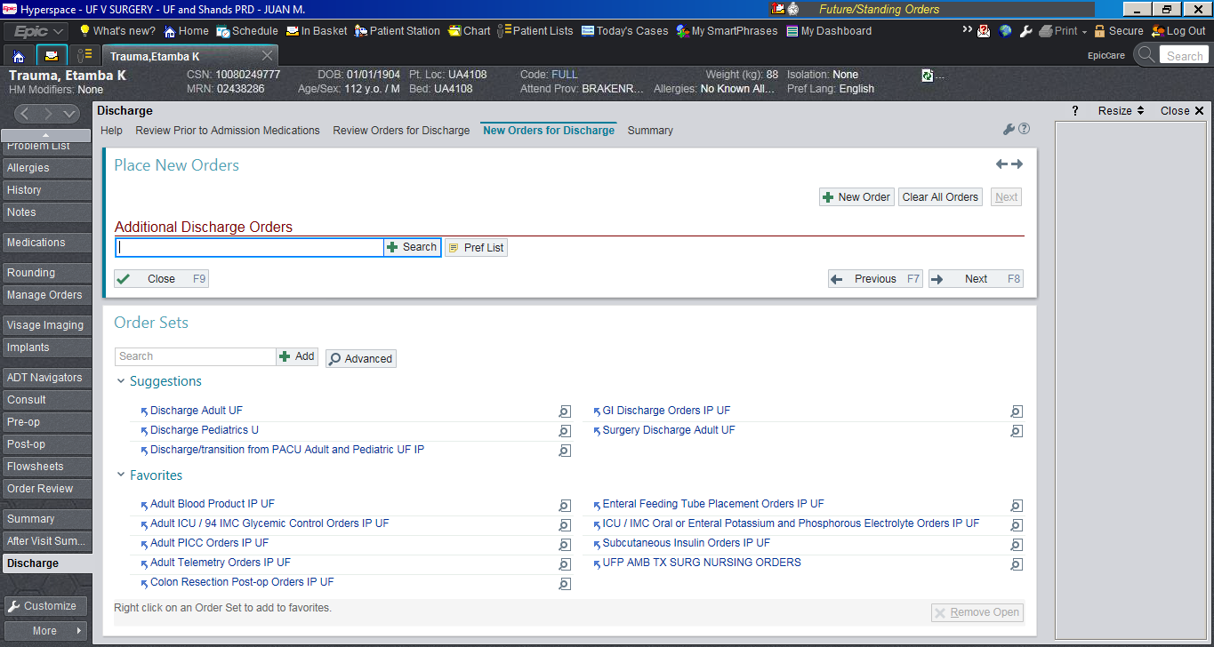

The “Surgery Discharge Adult UF” Order Set will be used by all Department of Surgery Divisions with the exception of Pediatric Surgery which will use “Discharge Pediatrics U”. Search for the appropriate order set under the “Order Set” text box.

Once selected, the “Surgery Discharge Adult UF” Order Set will open multiple orders for discharge. These will include: “ADT Orders”, “Notify”, “Activity”, “Diet”, and “Special Instructions”.
“ADT Orders”: Needed for patient to be discharged from the hospital. Requires disposition, data and time, and provider responsible for discharge summary
“Notify”, “Activity”, “Diet”: These sections are included in all Departmental patient discharge instructions, thus, they are pre-selected without need for further modification.
“Special Instructions”: New discharge instructions have been made for every division of the Department. These can be added here. Discharge instructions can be search as dot-phrases. The general rule is: each dot-phrase starts with the three letter abbreviation of the service, followed by DCI, then the instruction’s title. Example: .CRSDCIILEOSTOMY Colorectal Surgery (CRS) Discharge Instructions (DCI) for patients’ status post Ileostomy
Click on “Details” underneath “Special Instructions” to open the text-box.
A list of all discharge instructions can be found in the resident webpage: http://surgery.med.ufl.edu/education/general-surgery-residency/current-residents2/
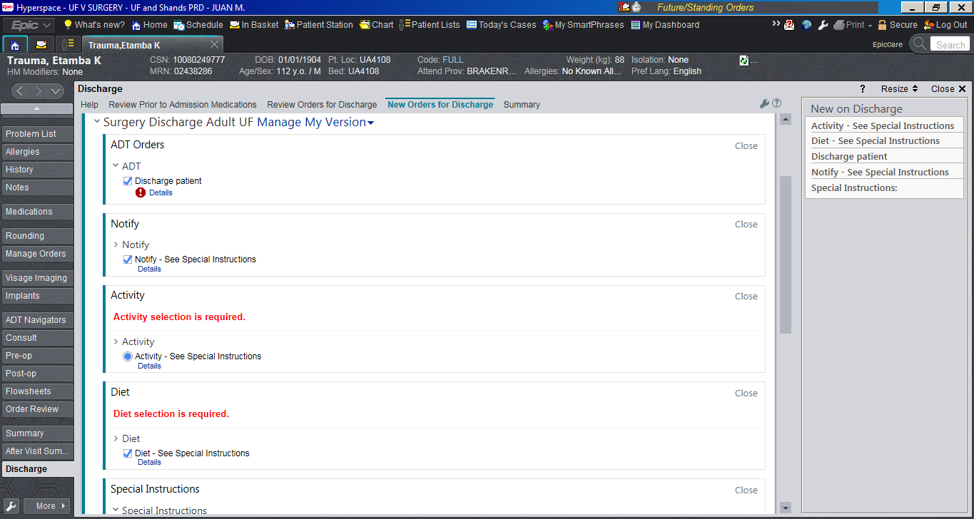
Scroll Down

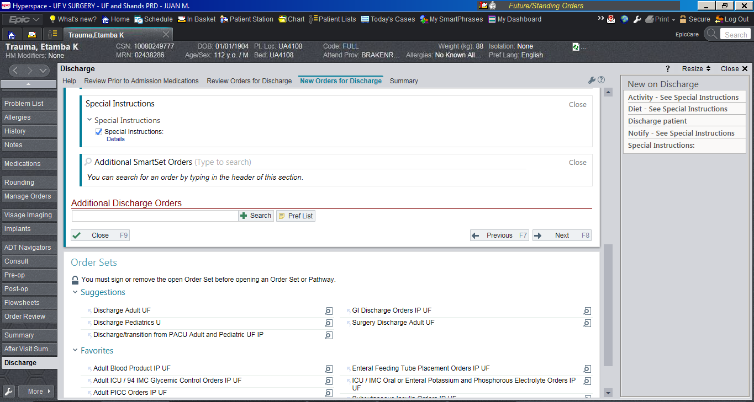

“Special Instructions”: Click in magnifying glass to expand size of the text-box for ease of reading. Erase the pre-populated text and input the new discharge instructions. Example: .CRSDCIILEOSTOMY.
READ DISCHARGE INSTRUCTIONS! Ensure accuracy for each patient. Most will need very little modification; however, each patient is UNIQUE and may require specific changes.
Only use approved discharge instructions which can be found for each division on the resident web page. (See above).
“Accept” new instructions and click “Next”.
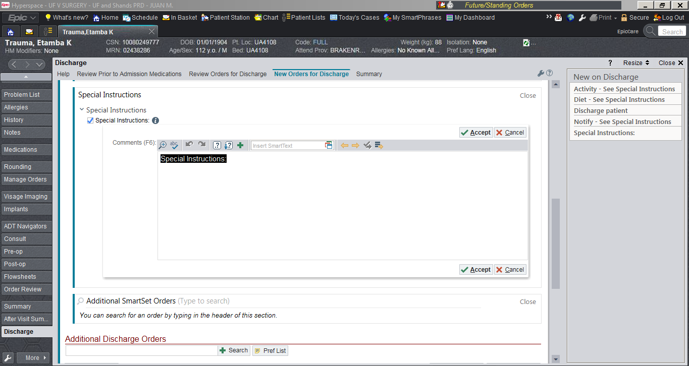

The “Summary” section should be reviewed to ensure all new orders on discharge are accurate. These can then be “Pended” or “Signed”.
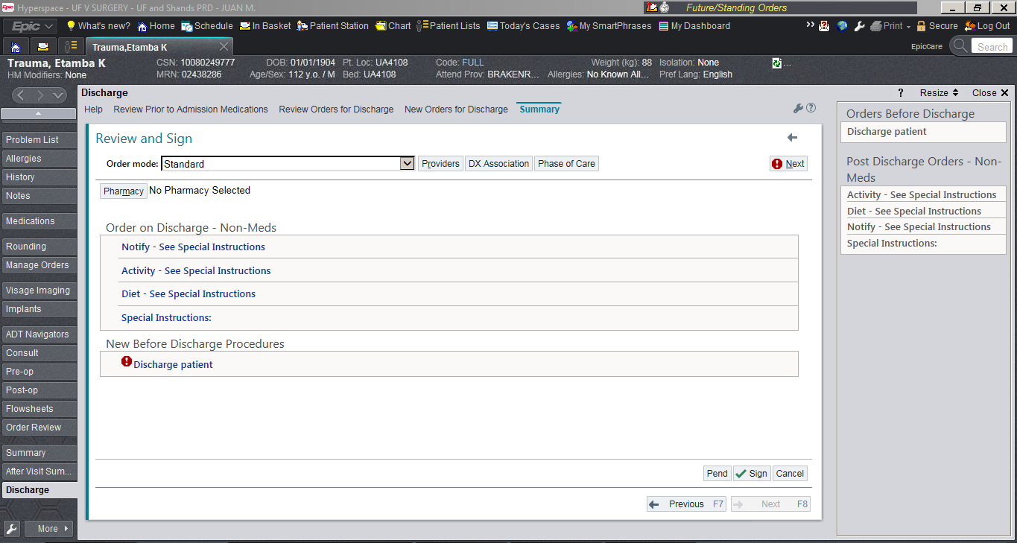

Click on “Preview AVS” to review the actual file that the patient will receive. Ensure that this file contains all the appropriate information for discharge.

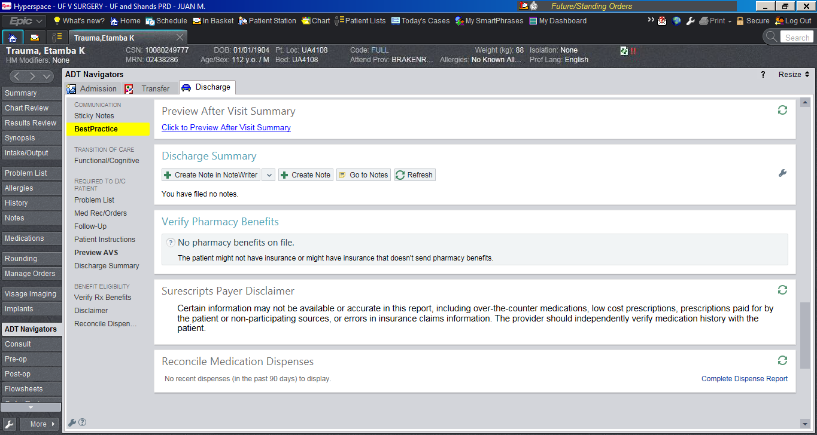

Review the After Visit Summary

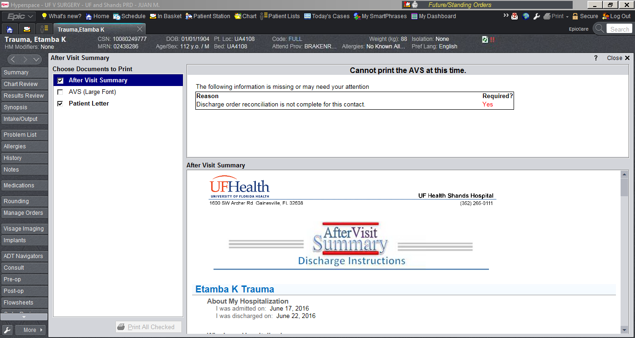

After the patient is discharged a “Discharge Summary” must be completed. Discharge summaries are required for billing and need to be completed soon after discharge. Each service has a specific template for the discharge summary. You will be instructed on which template to use at the beginning of each rotation.

