VA SICU/CTICU Tips

Attendings: Dr Grek, Dr Hobson, Dr Atteberry
Pharmacists:
General/Vascular/ENT – Ada (Karen covers when Ada is off)
CT/GU/Neuro – Matt (Christina covers when Matt is off)
Clinical Nurse Leader: Jamie
Dietician: Valerie

-On the schedule, it says ICU-A and ICU-B. One is supposed to cover Gen/Vas and the other intern is supposed to cover everything else and you switch after 2 weeks. Its up to how you want to split it; most people go by this general rule but try to even the patient load between the 2 of you so one isn’t carrying 8 CABG patients and the other is carrying 2 colectomy patients.

-Sign out at 5:45-6am, round with primary teams when they come. Most round at 6am, CT rounds at 6:45. You just have to look for them, they won’t come find you. After you round with them, put in orders for their patients. As far as transfer orders go, ask the primary team whether they want you to put them in or if they will. As a general rule, you will put transfer orders in for CT surgery and neurosurgery, GU and ENT will put their own in, and you just have to discuss with the interns on gen and vasc which way you want to do it.

-Prepare your systems-based presentations. ICU rounds are typically between 8 and 9, and you round with the attending, the pharmacists, Jamie and the nutritionist. After rounds, write your notes and prepare for your patients coming from the OR.

-There are no “blanket consents” here. Every procedure you perform has to have a separate consent for it. If an arterial line accidentally comes out, you have to re-consent the patient. There are 3 or 4 laptops in the unit with signature pads on them. If the patient is not consentable, find the next of kin in the chart and call Brenda at 6006 or 32-1764 and she will take care of it for you.

-Ordering AM labs: CBC, BMP, Mag, Phos daily. LFTs and Prealbumin Monday morning. AM CXR for CT patients. Always order labs as Ward Collect!!!

-The schedule for the next day is always printed out and sitting at the charge nurse desk in the center of the unit. The cases coming here are highlighted and are also written on the bottom of the staffing sheet.

-Don’t change vent settings without 1) telling the RTs and 2) changing the orders in CPRS.

-Finding your patients information can be difficult because not everything is in one place. Here’s a quick overview to help things go a little smoother on Day 1.

Labs: CPRS
Meds/Orders: CPRS
Vitals: The best way to find this is in Critical Care Manager. Sign in, click on the patients name (or type it in if it doesn’t show up on the list), then click Remote View. The first screen you come to will be the ICU Basic Flowsheet. This is a summary of basic details including vitals, fluids, etc. If you want min/max values for vitals, click on the clipboard at the top of the screen. This is the Patient Summary screen, and has every single detail you could possibly want on the patient and then some. The important things here are the vitals, oxygen delivery route, and lines.

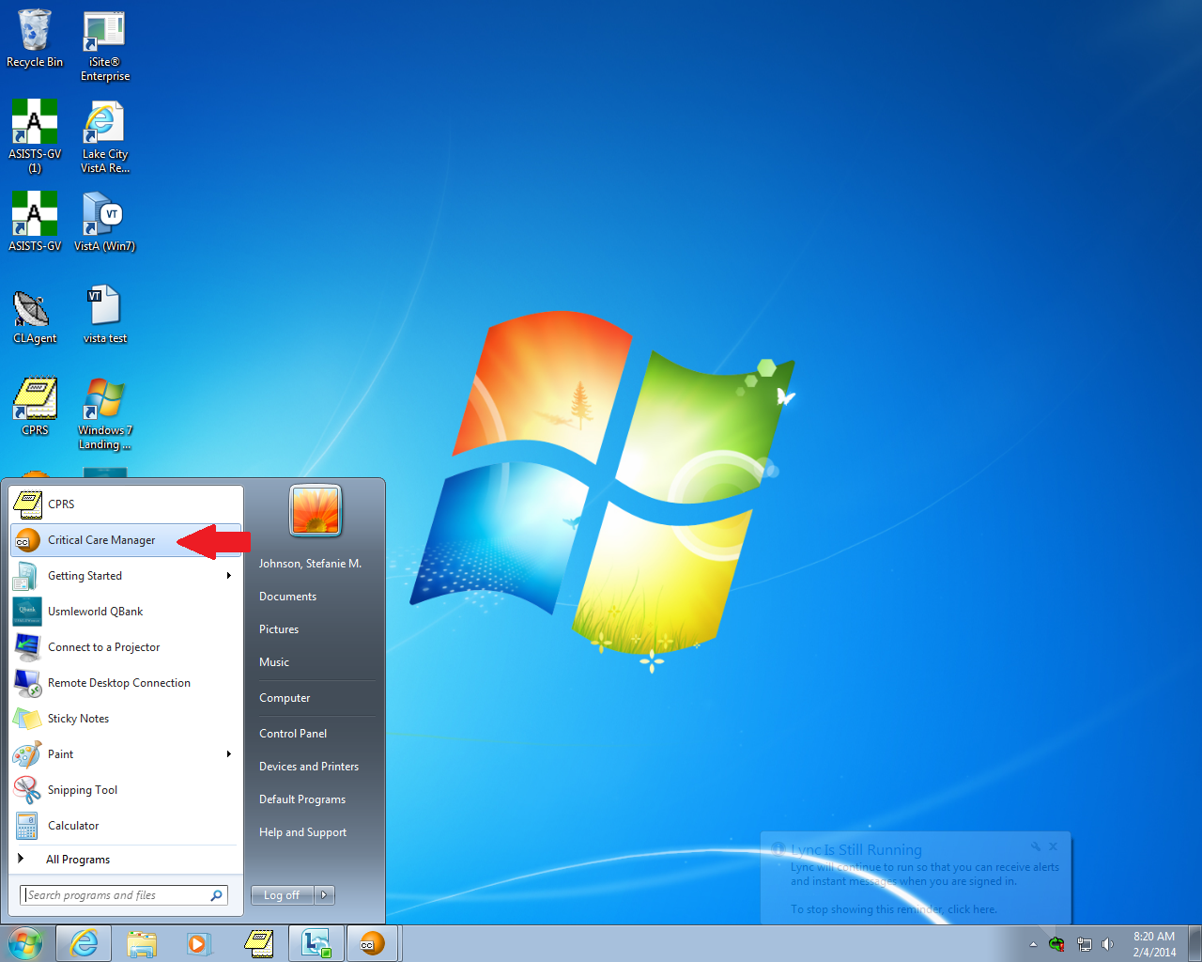
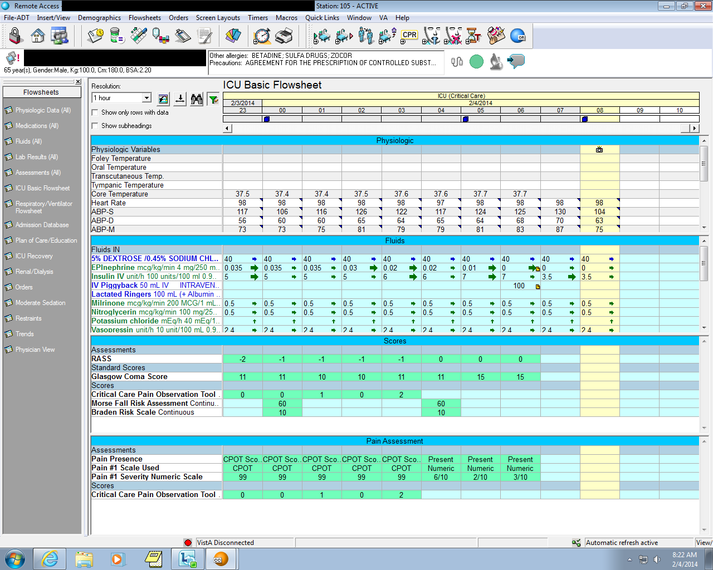

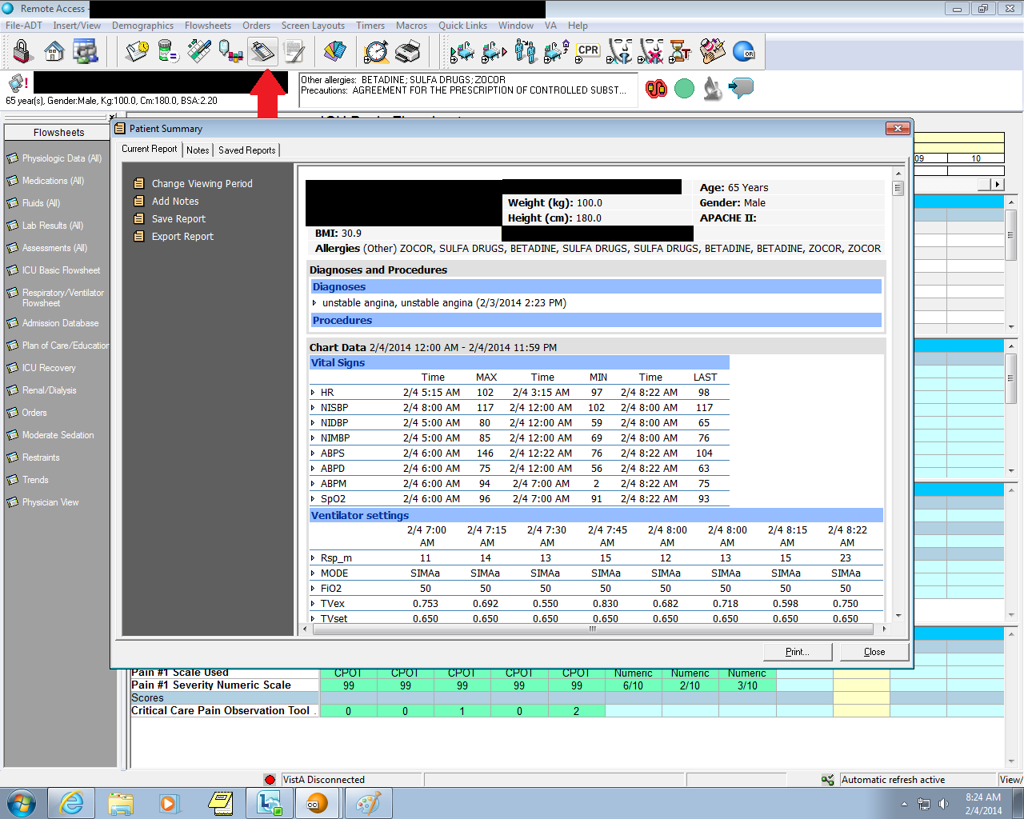

Fluids: On presentations, attendings want fluid numbers for 12am-12am for the day prior. Critical Care Manager will not show you this, but it will give you hour by hour fluids in addition to drains/chest tubes/urine outputs with cumulative numbers. The circled number is the cumulative, and this restarts at midnight so you can see the totals for the prior day for those things. (They are working on fixing this so everything is in one place). To get your 12-12 overall fluid totals, you have to go back to CPRS, click on Tools -> Imaging. Then find the ICU Flowsheet document. Once that is open, scroll to the bottom and click through until you see the totals on the bottom of the sheet (usually page 6-7). See pics below.

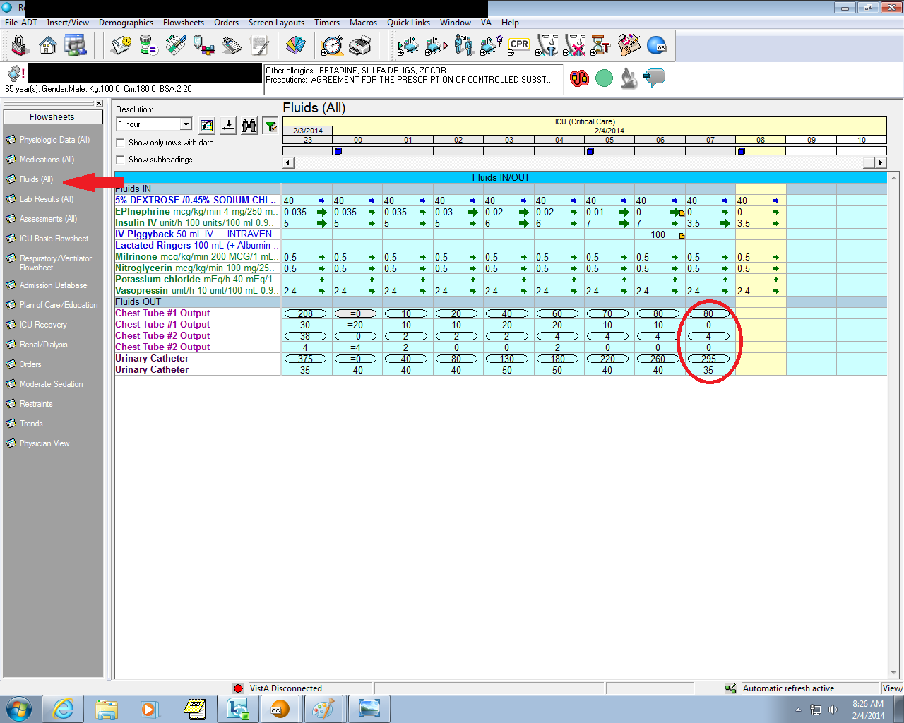
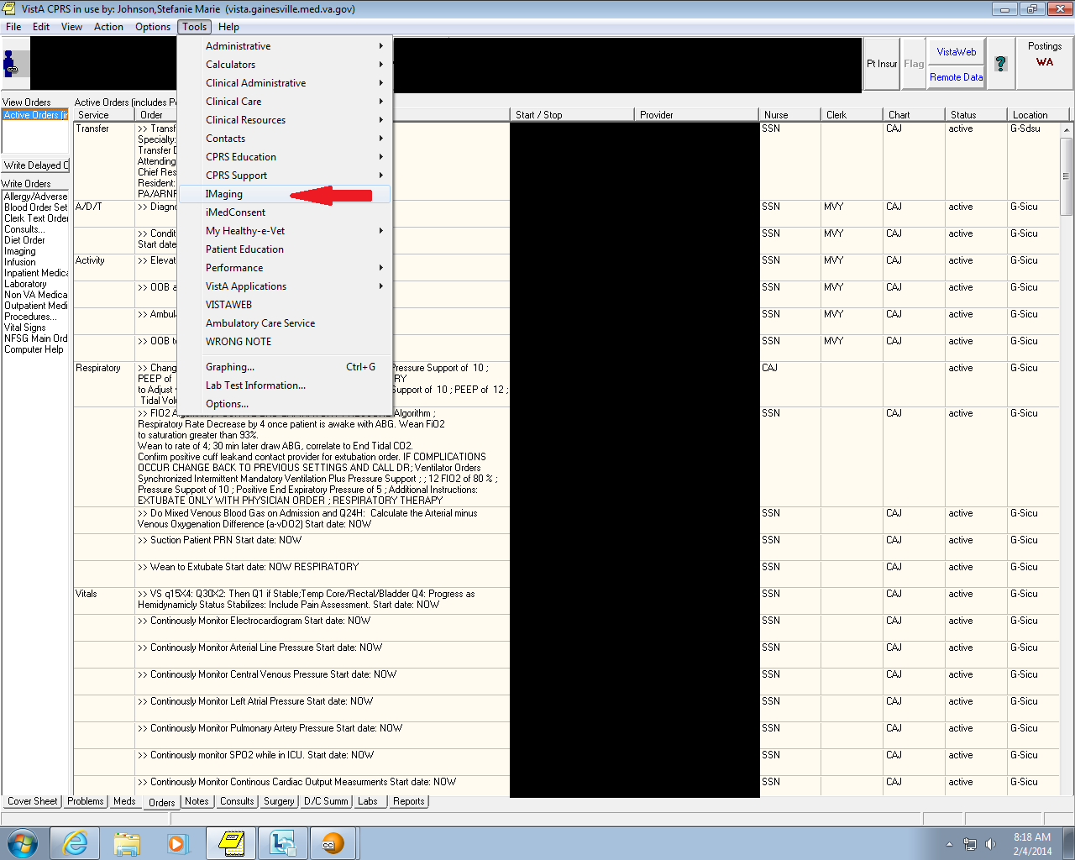
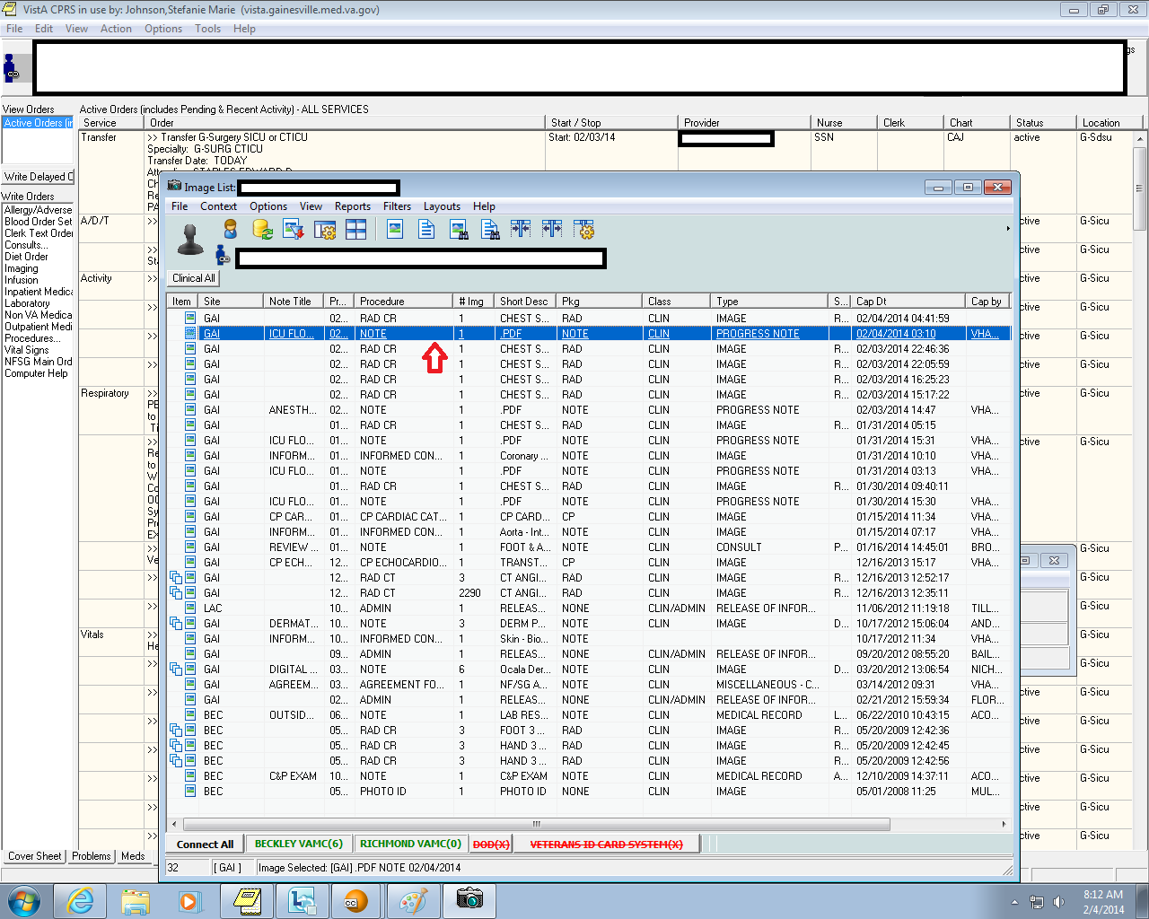
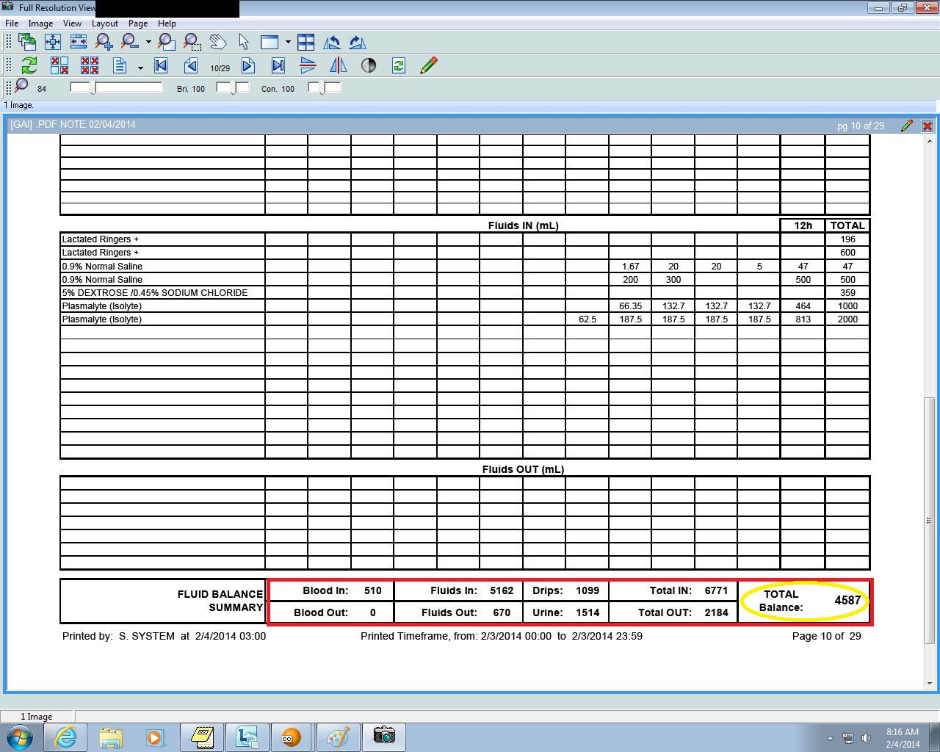
Orders: They have recently changed the ordering menus, and things can be hard to find if you are used to the old way. From the NFSG Main Ordering Menu, find the SICU/CTICU tab on the bottom right. From there, pretty much everything you need to order can be found here (except labs, meds, diet etc which are already easy to find on the left sidebar). The most commonly used ones have been circled. Take note of CIWA and Blood Glucose Management on the upper right – you will use these regularly.
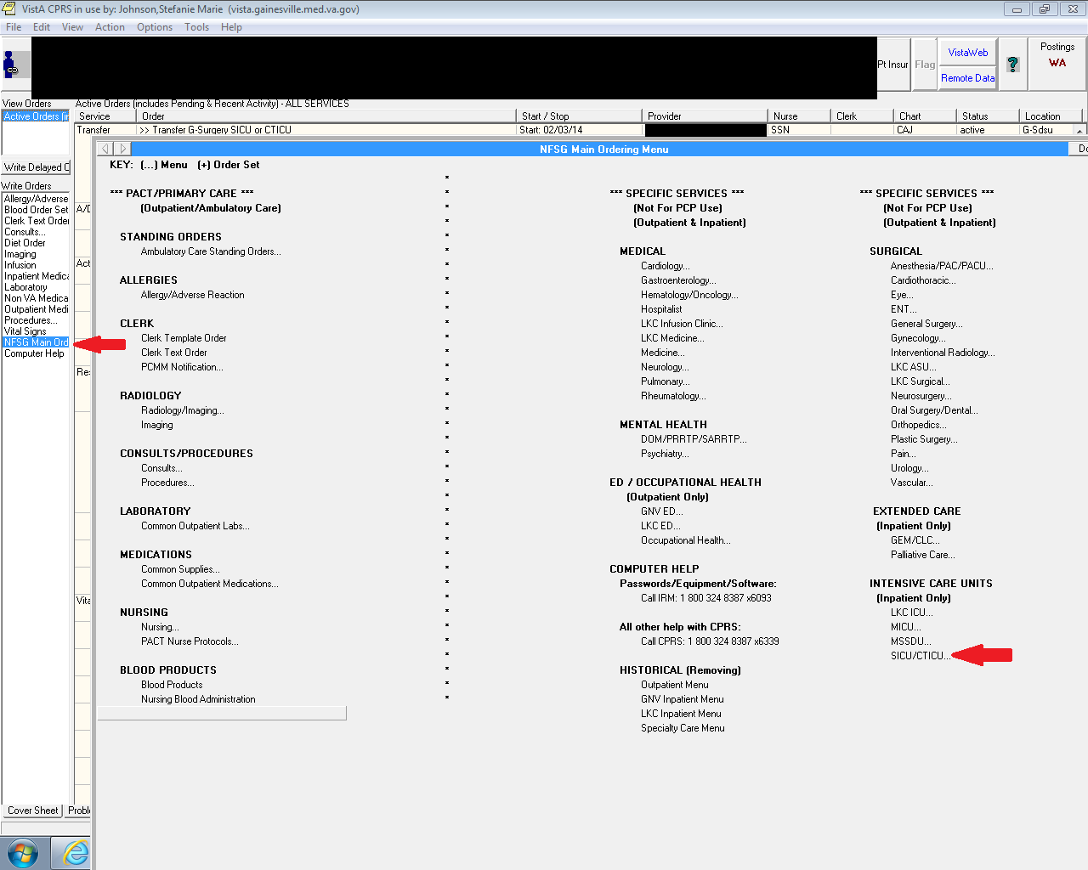
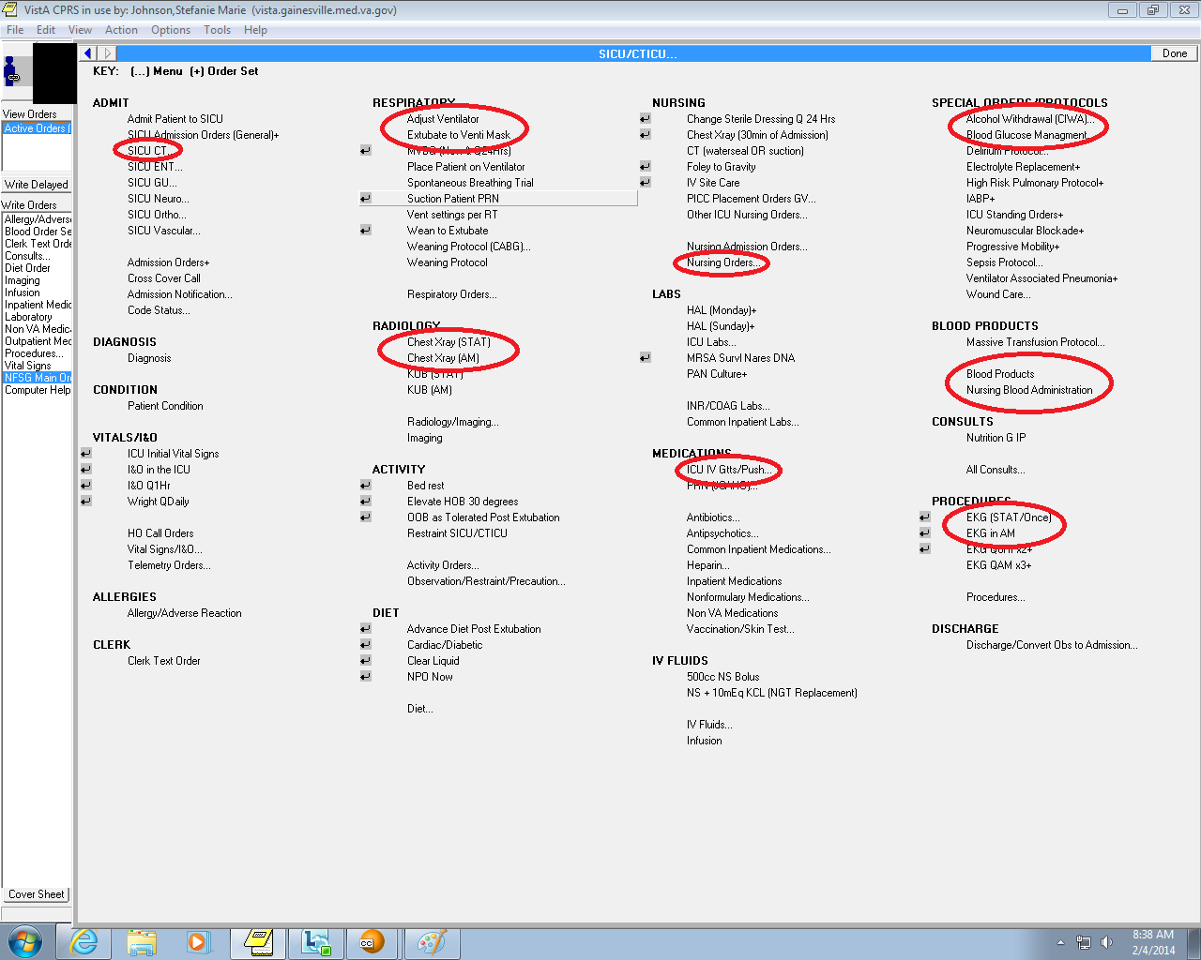

-Some extra points about orders - From the SICU/CTICU menu, under medications, you can click ICU GTTs/Push. This will save your life. Any time you have to order an infusion, go here. Every detail about the infusion rate, dose, etc is already entered for you. You just have to review it and make sure it is correct before accepting the order. The only thing you have to do is click “all bags” (see picture).
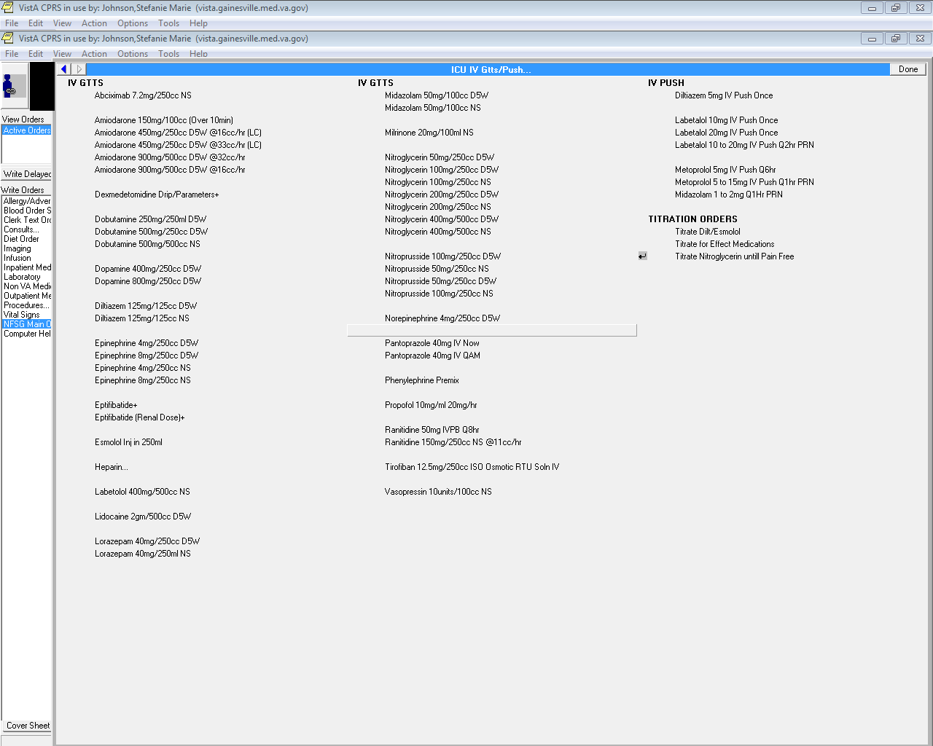

Keep scrolling…
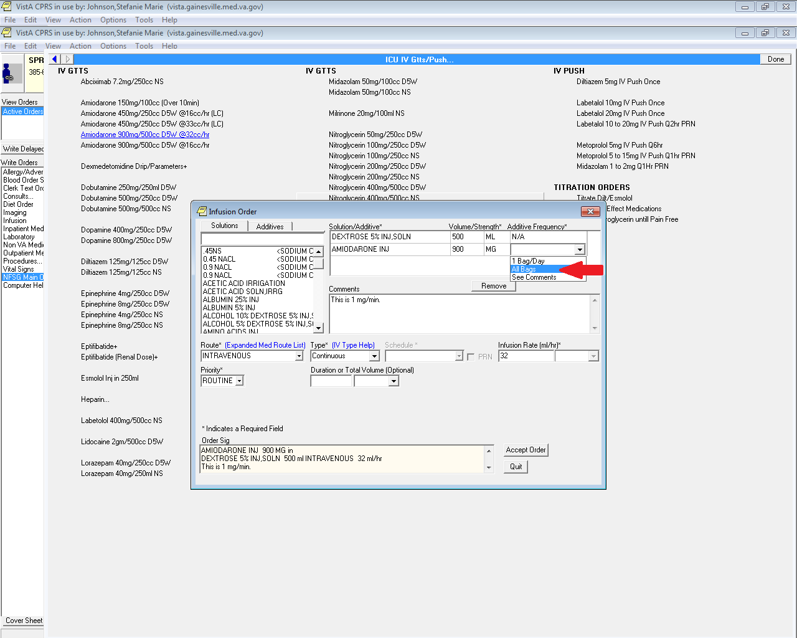

-CT surgery patients can be complicated, and there are some special things that you need to know and/or do for these patients. There is a list of general guidelines hanging on the wall in front of the computers in the unit for reference. It is very helpful and you will use it daily. The only other thing that will make your life easier is the POD1 Med Order Screen. Refer to the guidelines sheet in the unit for differences in orders for Stinson/Staples patients.
NFSG Main Ordering Menu -> SICU/CTICU -> SICU CT -> Medications to Start Post Op Day 1
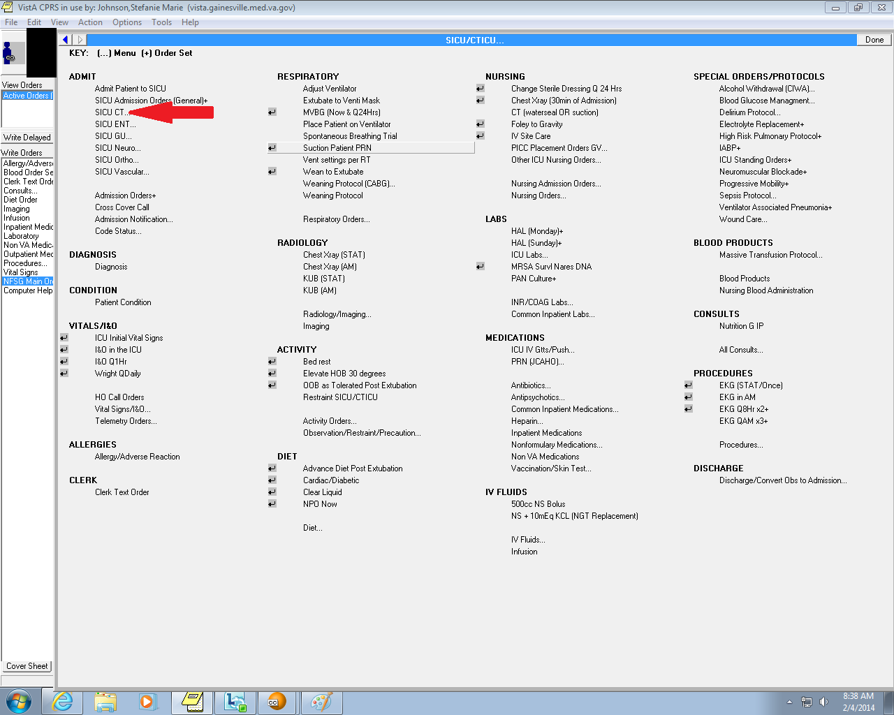
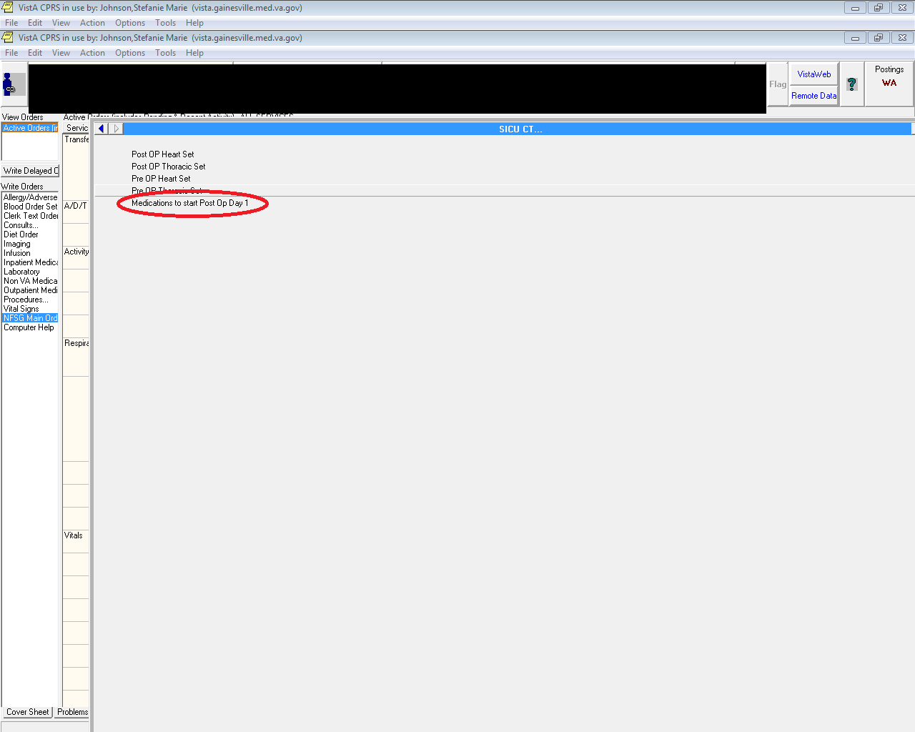
Finally, for CT patients you will want to know the more detailed physiologic data, like PA pressures, LA pressures, CI, CO, SvO2, etc. The only place to find this info is back in Critical Care Manager, then click on Physiologic Data on the left side. If you scroll through, all of this info is here.
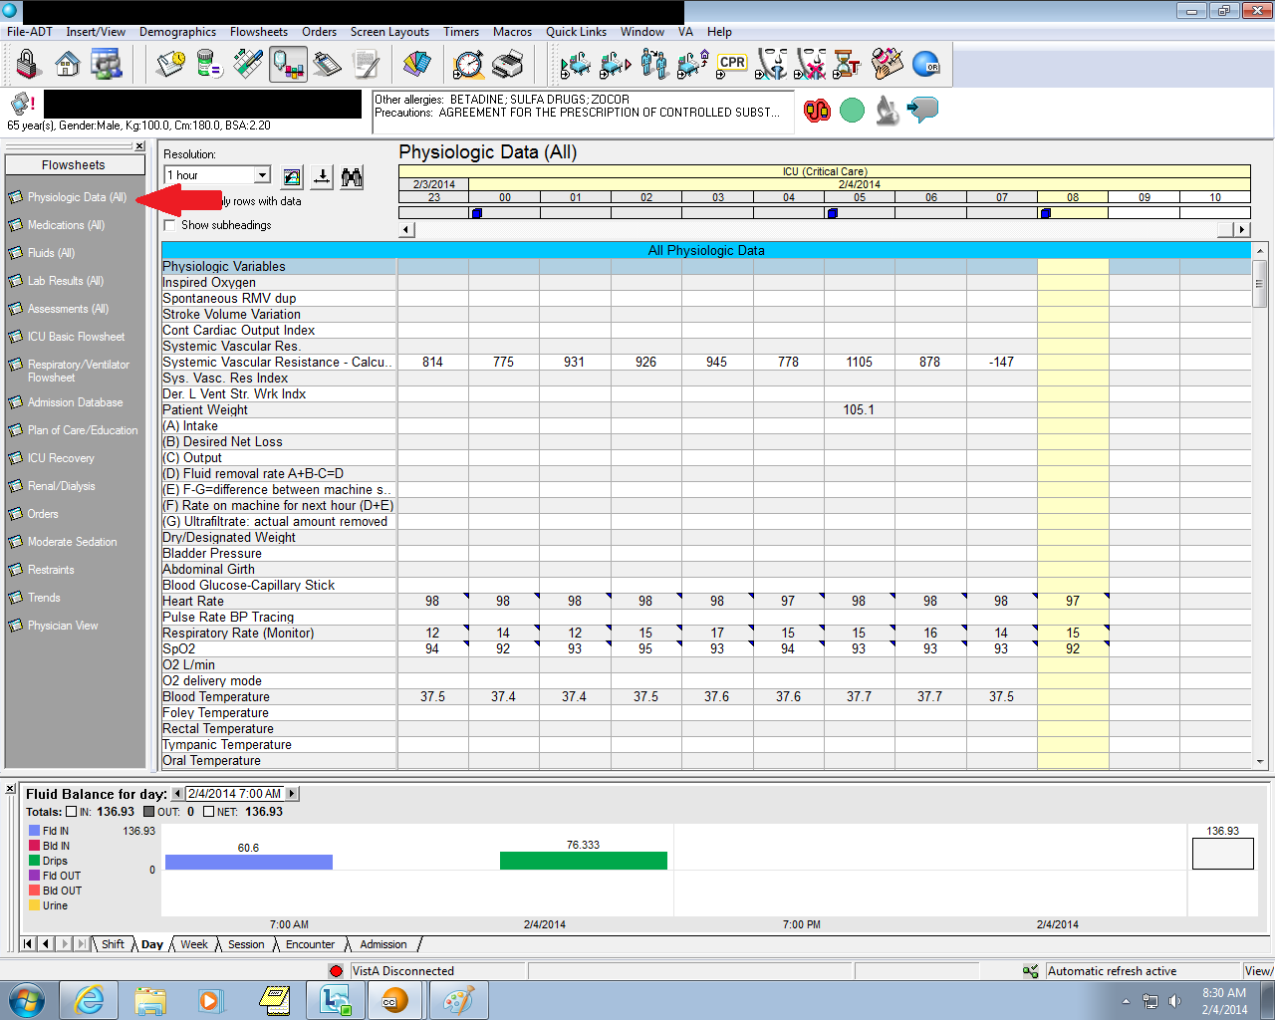
Also noted on this screen is fluid balance at the bottom. This is not from physiologic data, this comes up by clicking on the tab at the top that looks like an IV bag with some colors next to it (to the left of the clipboard). If you want to see fluid balances since 7am, this is the place to go.

Overall, this is a great rotation and you will learn a lot of very valuable information!!!

