Go to UFHealth Bridge and sign in with your GatorLink or Shands log in.
In the top right hand corner in the Search Box, type in:
COM Surgery – Abdominal Transplant

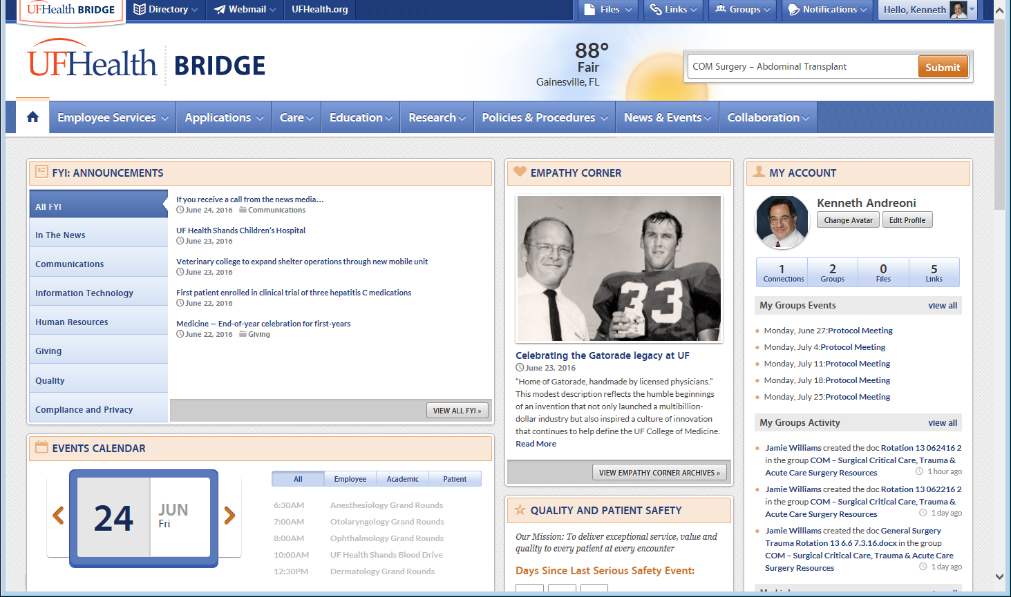
Cick ‘Submit’ and this page will appear:
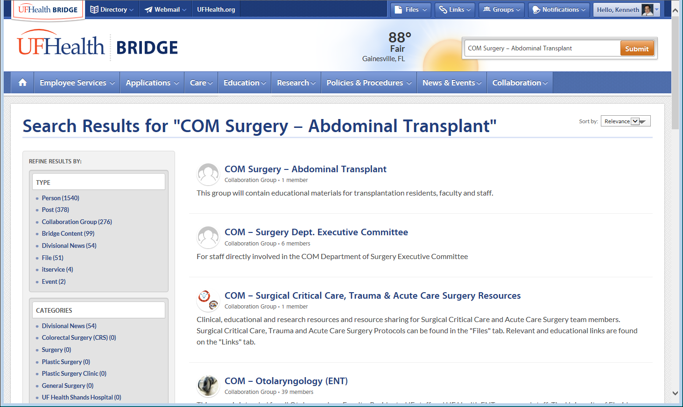
Choose the first one above “COM Surgery – Abdominal Transplant” group
A request window will then appear. Please request to be a member of the group.
An email will go to one of the administrators of the webpage, and we will give you permission to see the transplant page.

After you have been granted access to the group, you then log in and will see under GROUPS, that you belong to COM Surgery – Abdominal Transplant and you can click that link and go to our page. On our page, you want to go to “Files”.
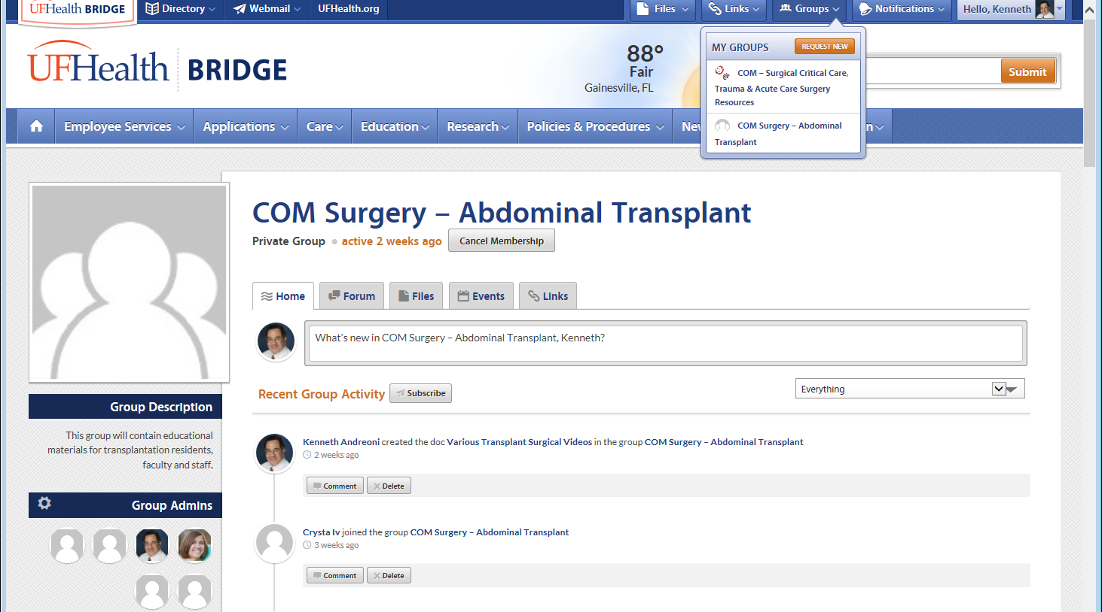

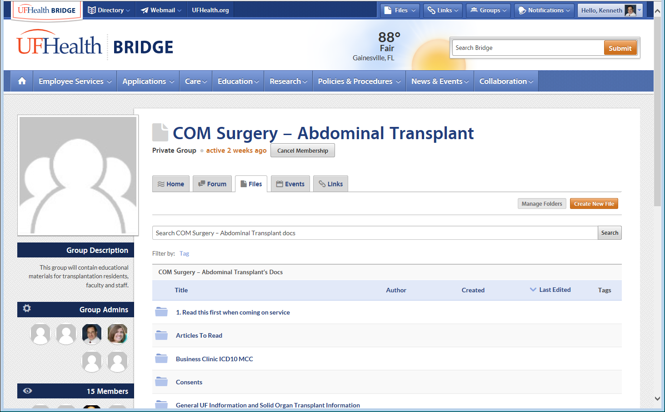
There are multiple files or folders here. You can open the folders and read the information available. There is helpful background information, articles, videos and a link and instructions to the American Society of Transplant Surgeons Resident Curriculum. This has narrated powerpoints and videos about transplant basics and operations. It is a very good reference.

Start with the obvious “1. Read this first when coming on service”
We are trying our best to help you understand the nuisances of transplant patient care, and provide easy ways to learn – narrated powerpoints and videos, as well as standard articles.
Our immunosuppressive protcols are all there also. We have consents you can also print off or copy as needed. There is a lot of information available to you there. Let the night floats know about this also.
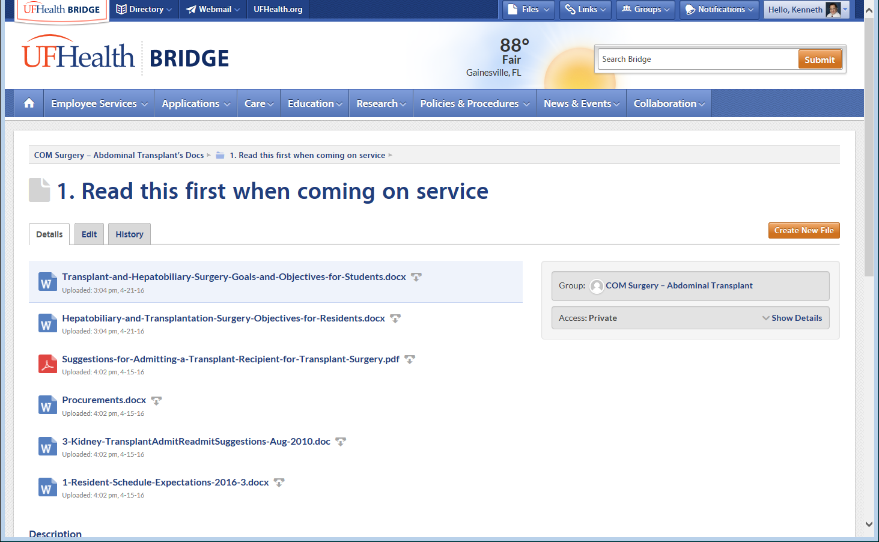

Call or email Ken Andreoni if you are having trouble with the site.
kandreoni@ufl.edu
Thanks

